Use-Case Realization Report
Delete Page

Issue <1.0>
Revision History
Date | Issue | Description | Author
12/10/09 | 1.0 | Initial Version | Rajendran Kumaraguru

Table of Contents
1. Brief Description 4
2. Flow of Events 4
2.1 Standard Flow 4
2.2 Exception Flow 4
3. Interaction Diagrams 4
3.1 Collaboration Diagram for Delete Page 4
4. Participating Objects 5
5. Class Diagrams 5
5.1 Class Diagram for Delete Lesson 5
6. Derived Requirements 6

Use-Case Realization Report
Delete Page

Brief Description
Portal admin will be able to perform the deletion of the page if it is no longer needed or the subscription of the service is expired.

Flow of Events

Standard Flow
- Portal Admin log into the system, and go to Page Admin Page.
- By clicking the “btnDelete_Click” button, the Page maintenance screen will be invoked in order to delete the page and its content for the created page.
- Get page will be invoked for the particular site before proceed to delete operation.
- Validate fields will be invoked to validate the input page details for the deletion operation.
- Delete Page will be performing the deletion operation for the page.
- Delete Module will be invoked to delete module detail.
- Upon deletion operation the successful message will be displayed to portal admin.

Exception Flow
- If the page is not available for the deletion then the exception message will be thrown.
- Validate fields should display respective error message if there is any validation error occurred.

Interaction Diagrams

Collaboration Diagram for Delete Page
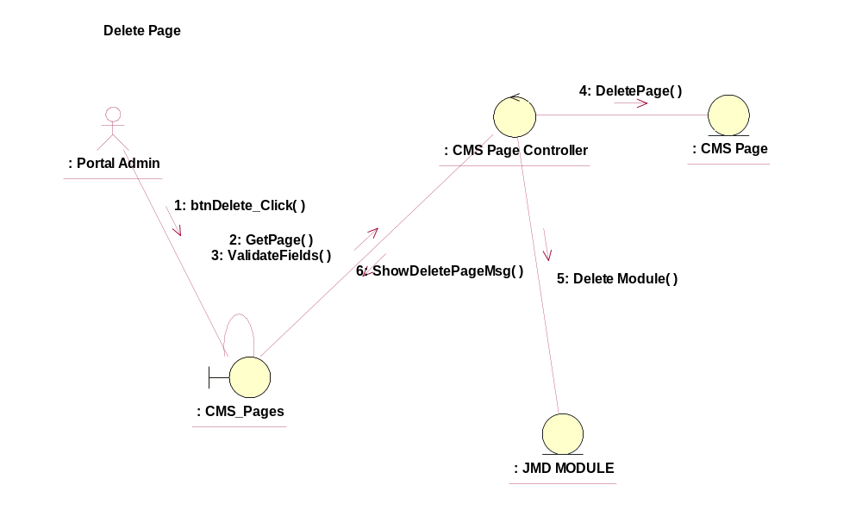

Participating Objects
: CMS_Page
This entity is the page object which will be used in JMD while creating the new pages after creating the outline.
: CMS_Page_Maintenance
This object will be used to create/delete/view/update the pages upon successful creation of the sites and outline.
: CMS_Page_Controller
This is the controller to add,modify,delete and view the page information.
: CMS_Page
This object will be storing the page information.
: JMD Module
This object will be saving the module information after creating the pages.

Class Diagrams

Class Diagram for Delete Lesson
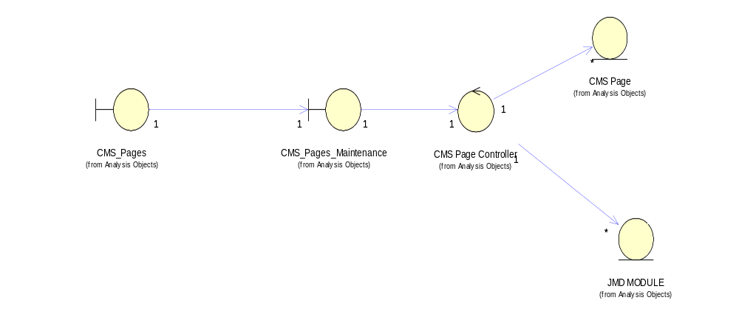

Derived Requirements
[enter the derived requirements here]

